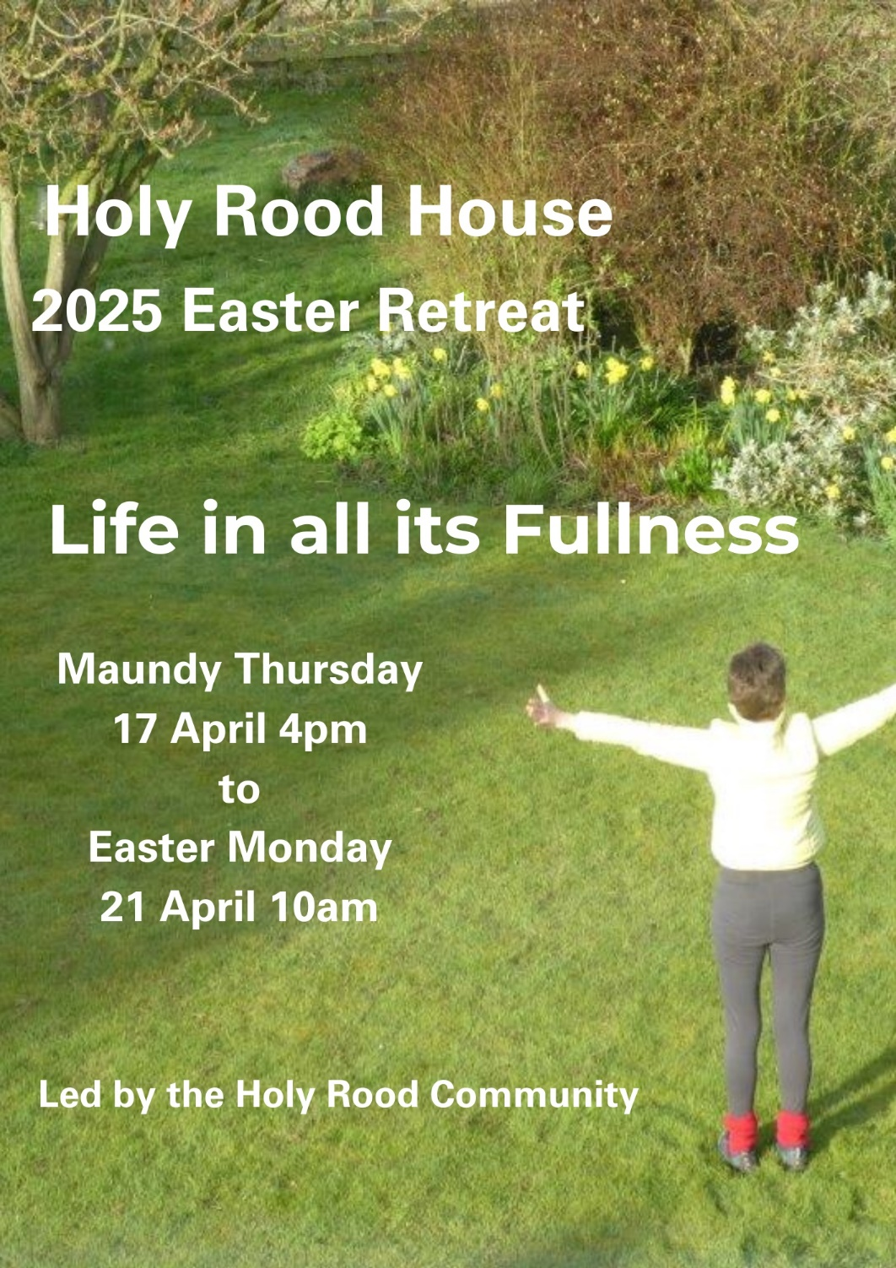
space to breathe ♦ time to pray ♦ food to enjoy
Booking Form: 2025 Easter Retreat
4pm Maundy Thursday - 10am Easter Monday

Send this information to: enquiries@holyroodhouse.org.uk or post the form to Holy Rood House, 10 Sowerby Road, Thirsk, YO7 1HX

Name/s (both names if sharing a room)

Address

Telephone Email

Please visit our website for more information about staying here

Please state which type of bedroom you would prefer;
the suggested donation is per person for the whole retreat:
- £470 (ensuite)
- £450 (shared bathroom or sharing a twin bedroom)

We ask for an £80 non-returnable deposit to secure your booking.

If you pay by BACS please let us know in your email or tick here: ___
BACS details - HSBC plc: Sort Code: 40-28-16 A/C no. 41227572
Centre for Health and Pastoral Care. Reference Surname17APRIL

Cheques payable to Holy Rood House

We can claim Gift Aid if you are a UK Tax Payer Y / N

In case of a medical emergency who should we call?

Have you stayed here before? Y / N

How did you hear about us?

