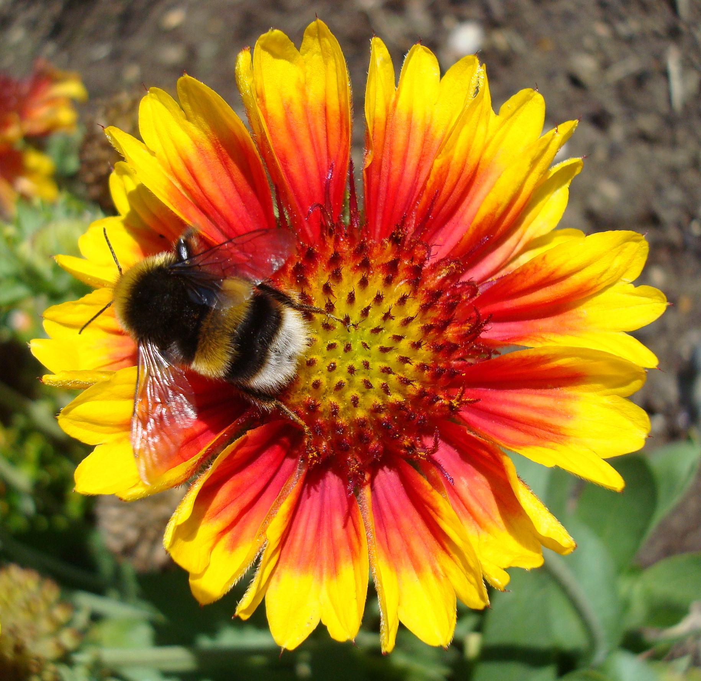

Holy Rood House, Thirsk, welcomes you to

***Replenish***

**A day of refreshment**

**Thursday 20th September 2018**

from 9.45 for 10am – 4pm

**Come and enjoy a day at the peaceful centre of Holy Rood House (and Thorpe House) - we specialise in health and pastoral care.**

**The day will have a gentle theme and is for anyone wanting more refreshment in life.**

**Chur Sun (one of our counsellors) and Helen (one of our chaplains) will run the day.**

**There will be space for sharing with others in a confidential setting and time to relax. Holy Rood has lovely facilities including a big garden, art room and library. The day will include lunch and hot drinks and will finish with tea and cake.**

**These days are run regularly throughout the year.**

Holy Rood House is a charity with a gentle Christian ethos; we are a community that offers a space for many people at their time of need. Comments from guests include ‘*I came tired, I leave refreshed and renewed by hope.’ ‘*…*the house has ‘held’ me, the garden has cheered me and the art room has freed me from worries & responsibilities. Good food & the love of so many people here has given me a sense of wellbeing…’*

Suggested donation for the day - £35 -£40

***Holy Rood House & Thorpe House***

***Centre for Health and Pastoral Care***

***& The Centre for the Study of Theology and Health***

***10 Sowerby Road***

***Thirsk***

***YO7 1HX***

Do explore our website <http://www.holyroodhouse.org.uk/> or give us a ring **01845 522580**

[**enquiries@holyroodhouse.org.uk**](mailto:enquiries@holyroodhouse.org.uk)